# Progress Mobile: How to Update Exemplar Standards

## Uploading Exemplar Standards through the Progress Mobile Application

### Uploading Files

Updating Exemplar Standards within Frog Progress has never been easier than when using the Frog Progress mobile application. This guide will take you through the process of updating Exemplar Standards within the Learning Locker using the Progress mobile application.

**Note: These steps will require both the Frog Progress mobile application and FrogSnap application. These can both be downloaded from the App store (iOS).**

The first step is to open the Progress mobile application and enter your Frog Progress platform URL. Once you have entered your URL you will be prompted for a username and password. Enter the same username and password you would normally use to access Frog Progress on a computer.

You will be presented with the following screen. Choose Update Exemplar Standard.

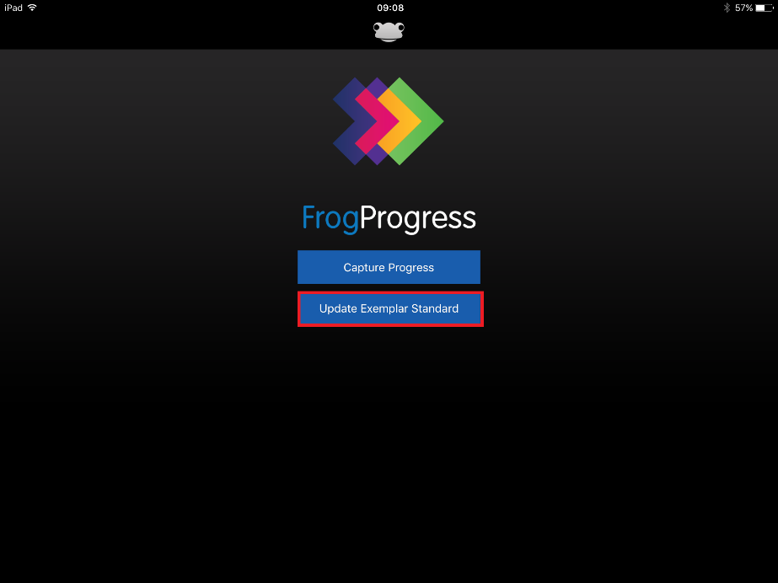

You will then be presented with a list of the available trackers created in your system.

**Note: It is important to create your trackers before attempting this tutorial.**

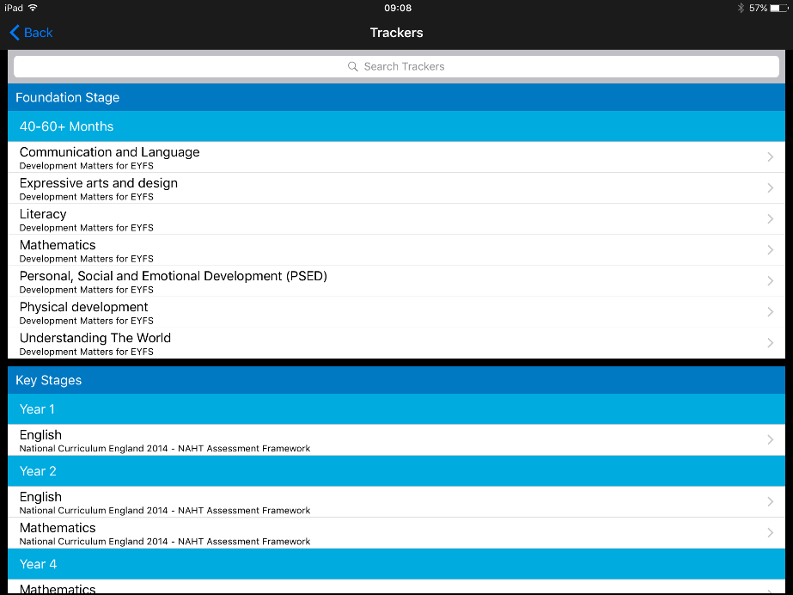

Click on the tracker you wish to update the Exemplar Standards for. You will then be presented with a list of learning objectives and KPIs.

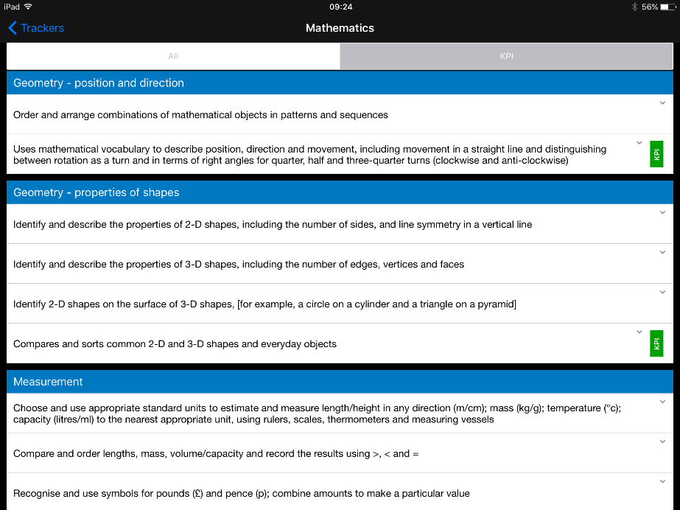

Click on the learning objective or KPI you wish to update the Exemplar Standard for. You will see a box appear under the objective with an “Add Evidence” button and the FrogSnap logo attached.

Click on this button to be taken to FrogSnap.

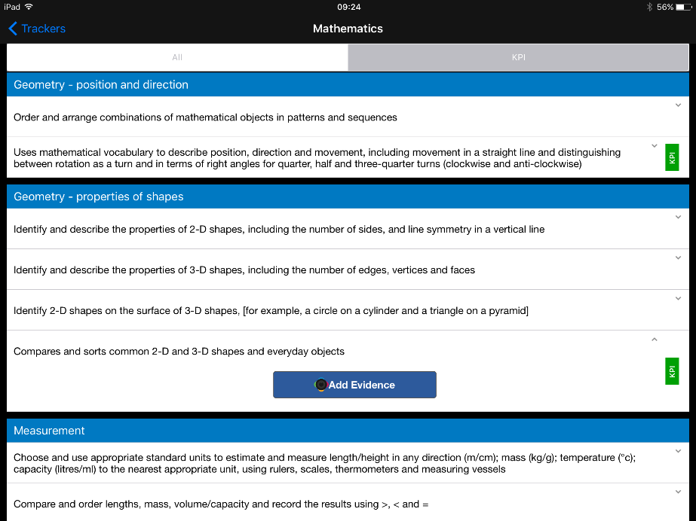

Once within FrogSnap you will be able to take a picture of the piece of work that you wish to add as an example of what good looks like. Use the blue button to take the picture. You can switch between pictures, video and audio using the black and white camera button in the bottom right corner.

**TIP: Be sure to leave enough space around the edge of the work on the photo so that you can annotate the file.**

Once you have taken your picture, you should see a small thumbnail appear in the bottom left corner of the app. Click on it to select your picture.

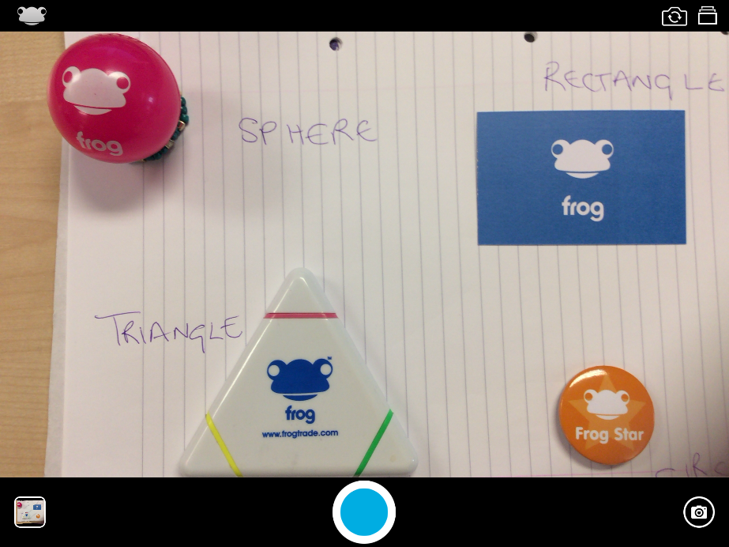

Within the next screen it is possible to either **edit** your picture to add annotations and notes, or to **upload** your picture without annotations. Adding annotations to the picture itself is a great idea because it enables you to make it really clear where the piece of work meets the standards expected by your school. Notes can also be added within Progress as text notes, but you may wish to add notes to the image to really clarify why this work is meeting the standards set.

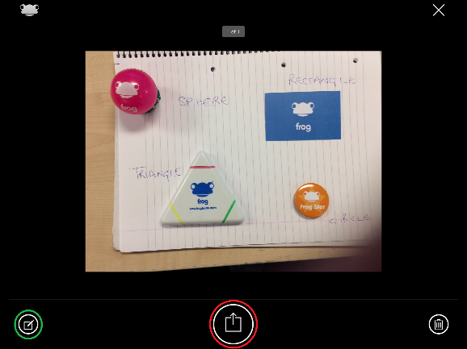 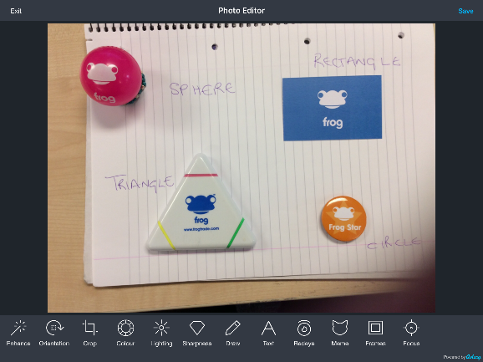

When you have edited your picture to your satisfaction, select the Save button to save your changes. You will then be directed back to the upload screen where you can use the central button to upload your image into the Progress mobile application.

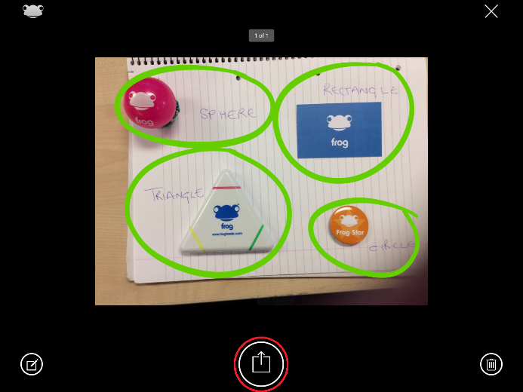

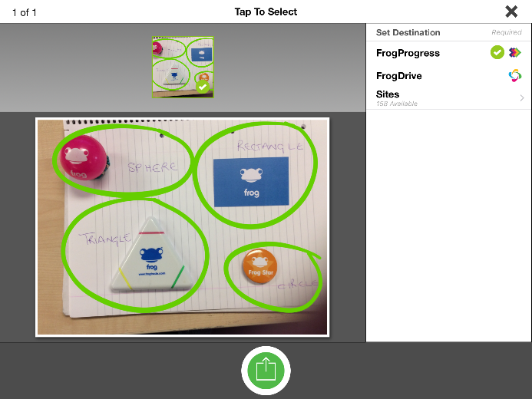

On the next screen, ensure FrogProgress is selected on the right hand menu and then use the green upload button to upload the image into Progress mobile.

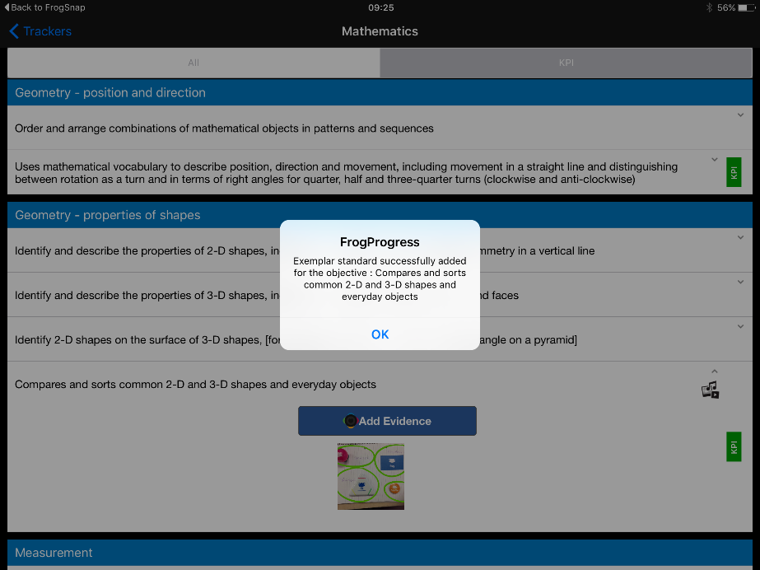

At this point, FrogSnap should bounce you back into Progress mobile and a prompt should be shown showing success or failure of the upload. Select OK to proceed.

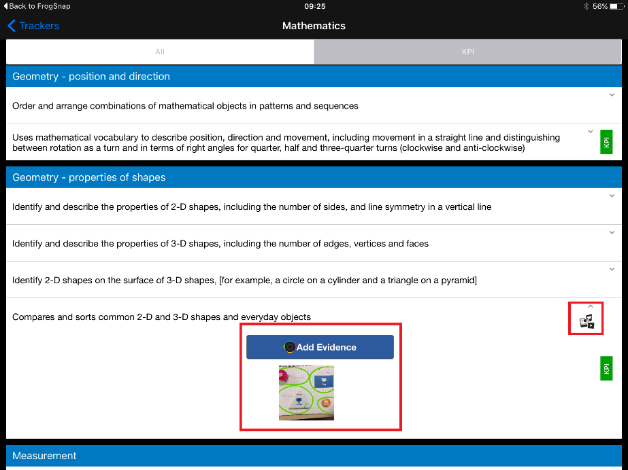

You should be able to see the image you have chosen to upload against the learning objective or KPI selected. There should be a media icon on the right hand side of the objective to indicate that there is a file attached to this objective.

At this point you have a choice. You can either continue to add more standards to different learning objectives within the same tracker, or you can upload the files you have.

**Note: Please make sure that you upload your files before leaving the tracker.**

When you are happy with the files that you have gathered for your tracker, scroll to the bottom of the tracker to get to the upload button which will add your Exemplar Standards into Frog Progress.

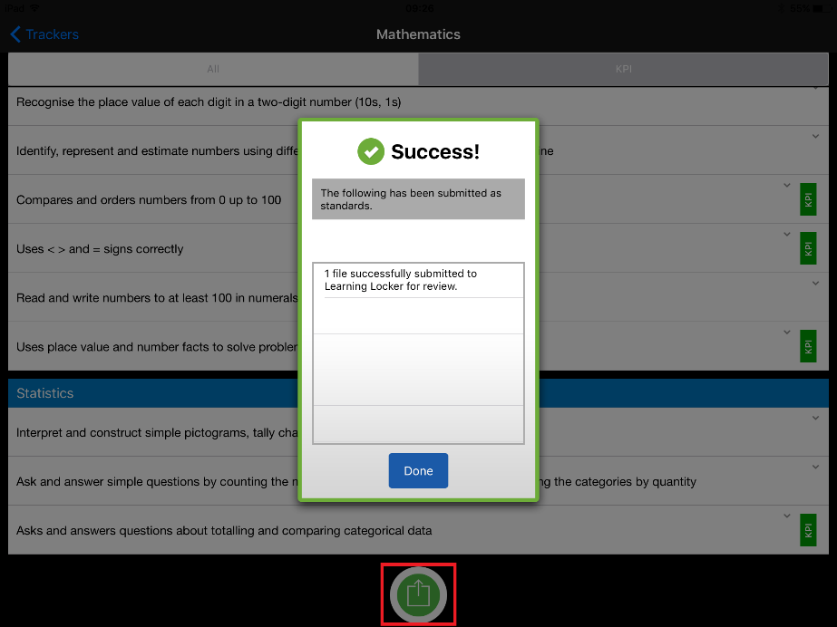

Select the green upload button at the base of the tracker and you should see a Success reporting screen which will let you know how many files have been submitted to the Learning Locker for approval.

This completes the process of uploading Exemplar Standards through the Progress Mobile application.

### Adding Notes

It is possible to add text notes to an image taken through the Frog Progress mobile application prior to uploading it into your Progress build. These notes are recommended to add context and commentary to your standard file.

To add a note to your file, follow the above instructions until the point where you have added your image against your learning objective or KPI.

When you can see the image under the learning objective, click and hold on the image with your finger. This will bring up an iOS style button which will give you the option to Add Comment or Delete the file.

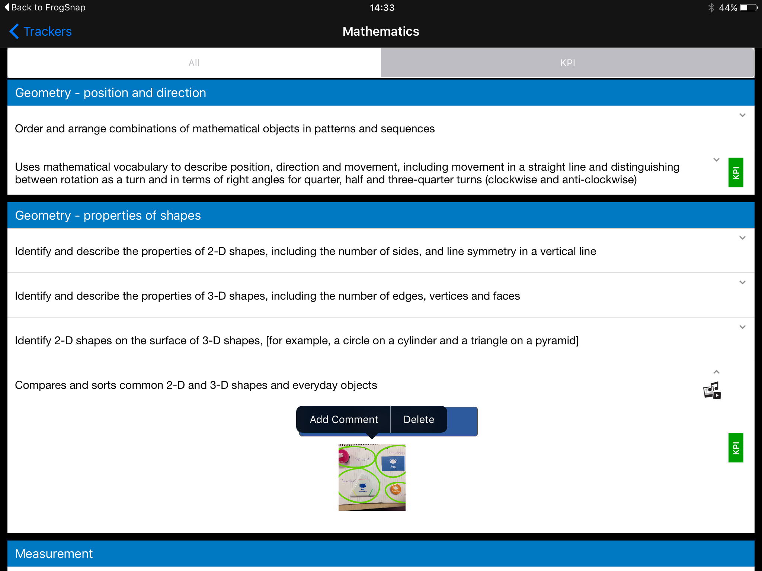

Choose Add Comment and you will be presented with a text screen where you can enter your comments.

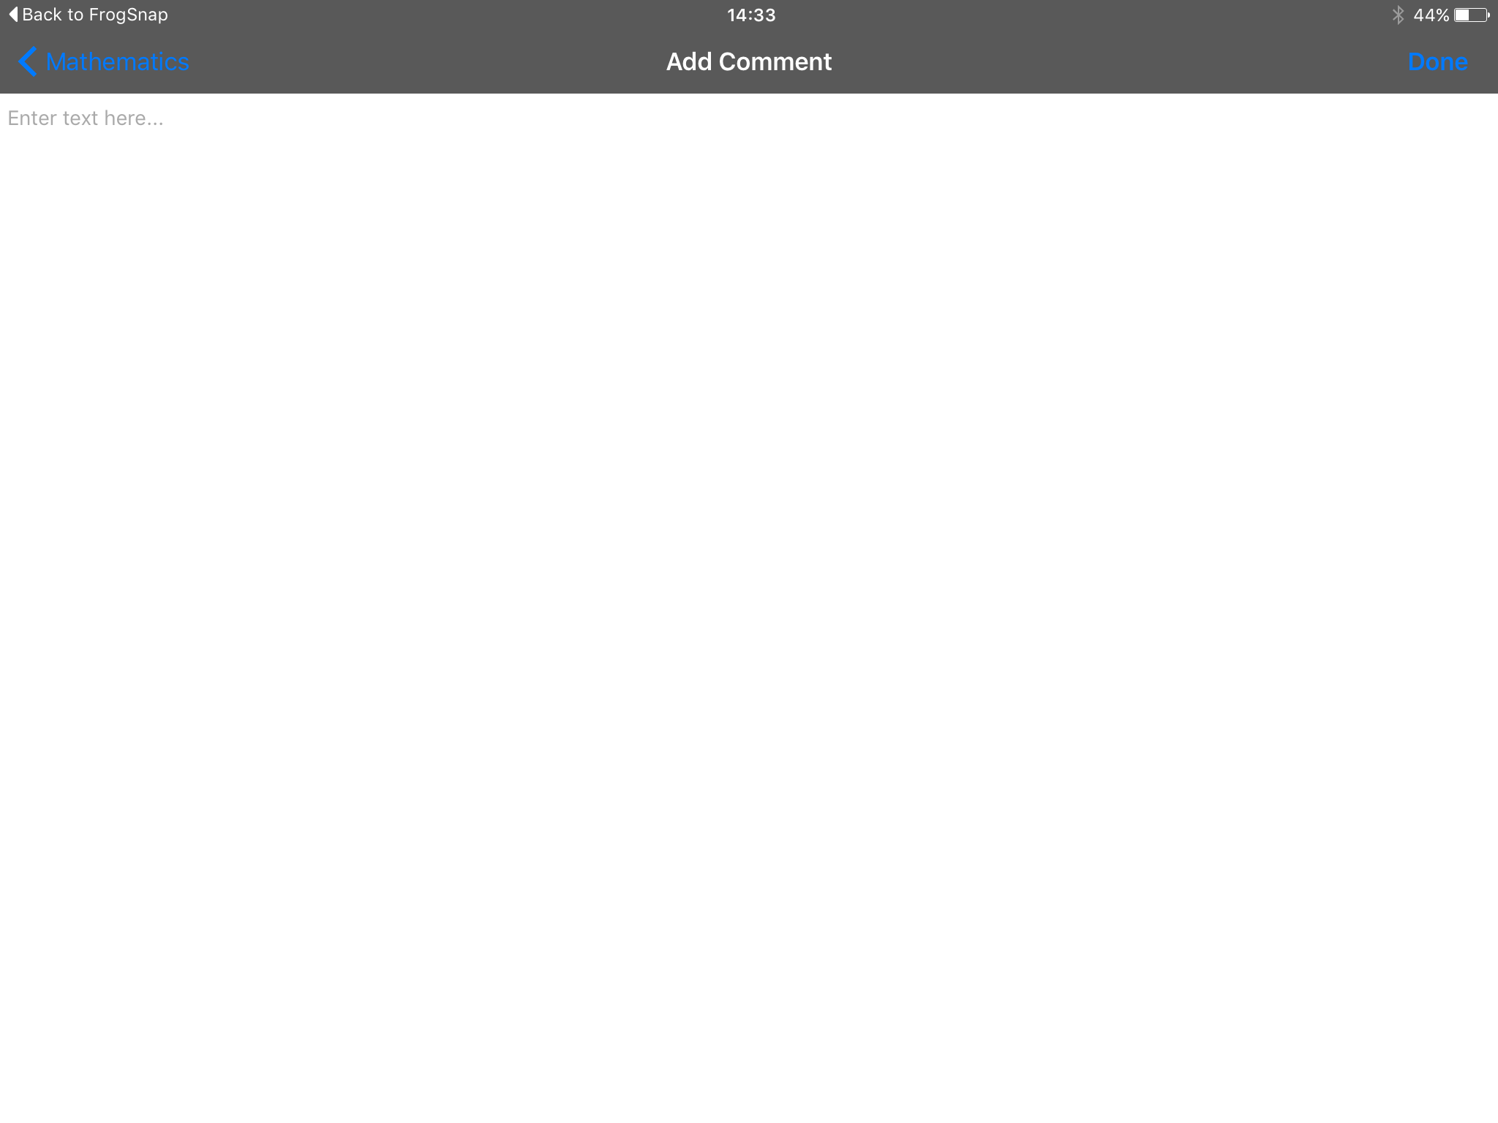

It is recommended that the comment is broken up into two sections:

* Context – What was the student doing when the work was produced?
* Commentary – Why does the work meet the standard? These comments should complement the annotations added.

When you have finished adding your comments select Done to complete the process.

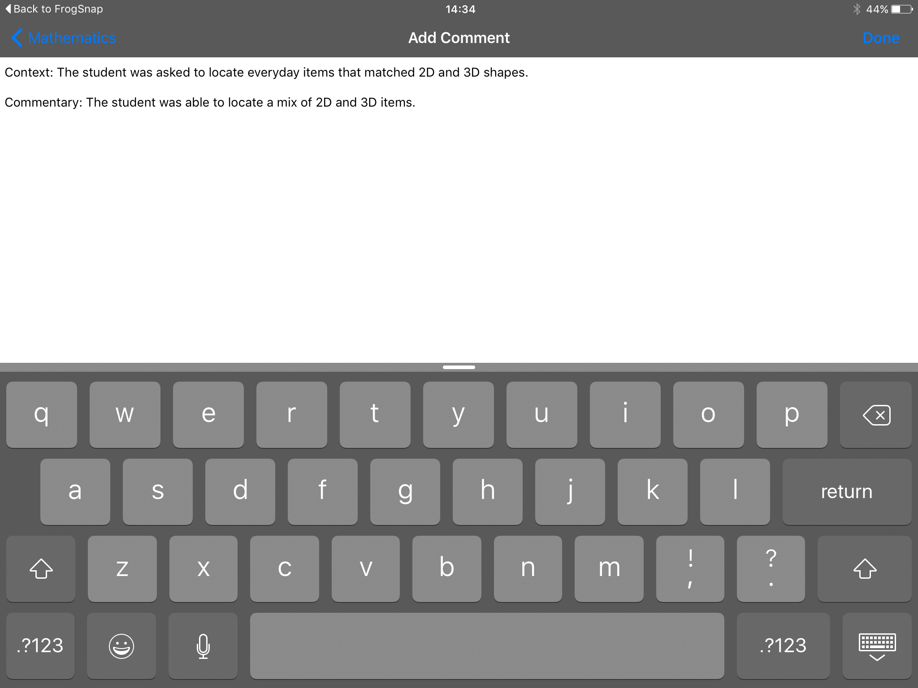

You will notice that the thumbnail of your standard now has a white speech bubble icon on it, indicating the presence of a comment.

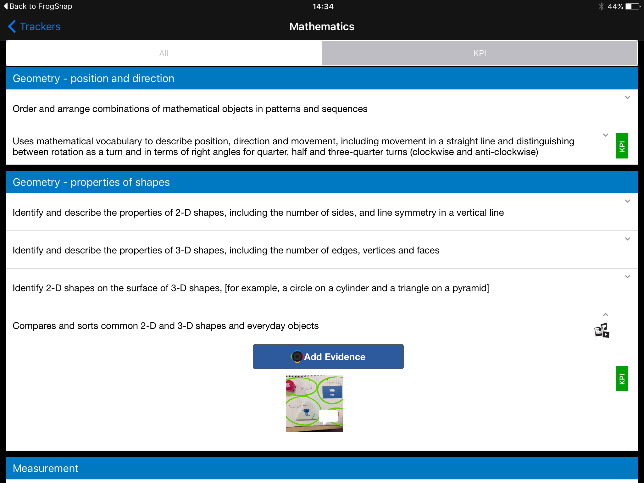

The file can now be uploaded as above for approval within the Learning Locker. The comment will appear next to the file within the Learning Locker like this:

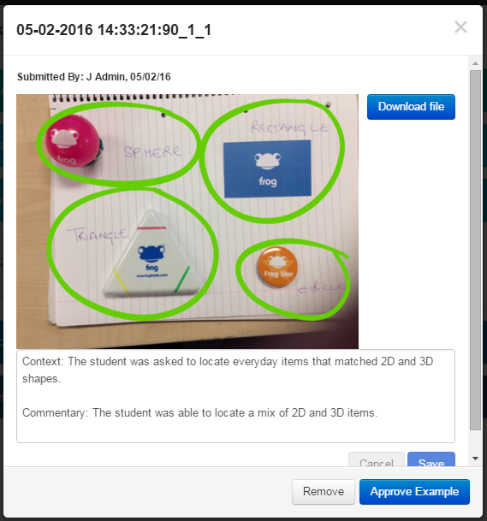

## The Approval Process

Once a file has been uploaded to the Learning Locker it needs to be approved before it is available to users who are able to view the Learning Locker.

To approve a standards file, log into your Frog Progress platform. Navigate to Curriculum Manager and locate the same curriculum and learning objective you uploaded your exemplar standard against.

**Note: Curriculum Manager is only available to administrators unless specific roles have been enabled for other users within the Groups and Policies application.**

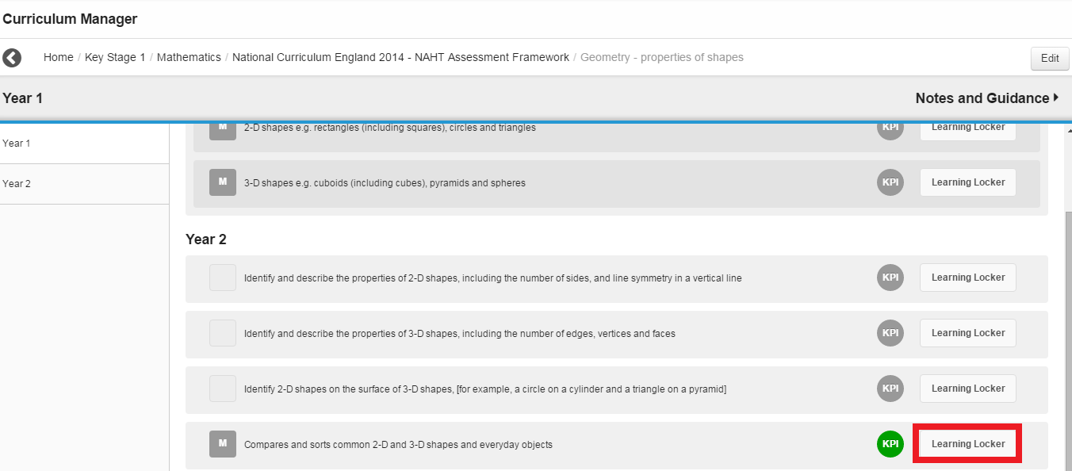

When you have found the relevant learning objective, select the Learning Locker button on the right. When the Learning Locker opens, choose the Exemplar Standard Materials section.

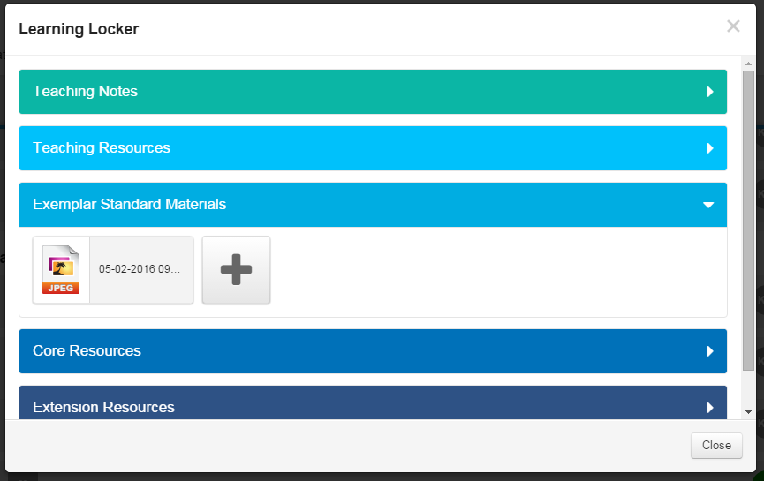

You should be able to see the file that has been uploaded with a file type attached. Single click on the file to open the preview and approval window.

In this window you can add notes to the file which might be a bit of background information or a description of the work itself. If your user account has the correct permissions, you will be able to see an “Approve Example” button in the bottom right of the new window. Selecting this check box will approve this standard file and will allow users to see this file in Student Tracker or the curriculum public view.

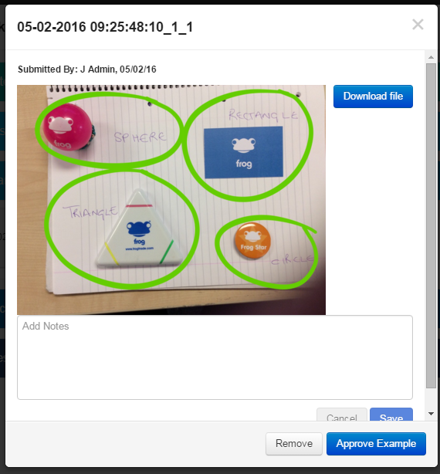

When the file has been approved you will be able to see a tick against the file. This means that it is easy as an administrator to see which files have and have not been approved.

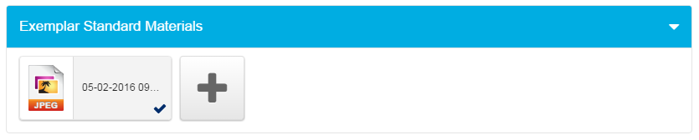

That’s it! Your exemplar standard is available against that learning objective or KPI for your staff to use while making their judgements.

## Removing an Exemplar Standard File

Occasionally it might be necessarily to remove a standard file, for example if in a subsequent moderation meeting the file is no longer considered to be the best representation of the standard for that learning objective.

To remove an exemplar standard, log into your Frog Progress platform. Navigate to Curriculum Manager and the relevant learning objective / KPI. Click into the Learning Locker and locate the file in the Exemplar Standard Materials section. Click on the file to open the preview window. If the file is already approved you will see a Remove button which will remove the file from the standards area. If the file has not been approved, you will see both the Remove and Approve Example buttons. Simply choose the Remove button to remove the file.

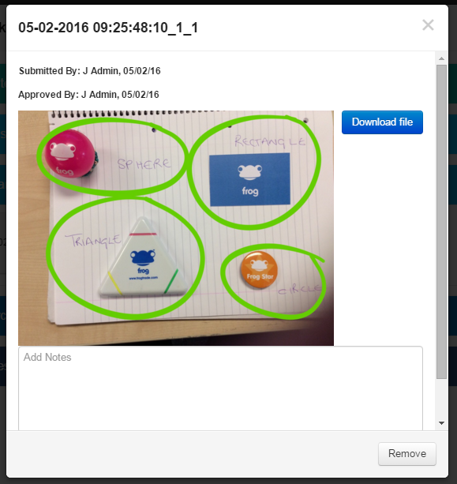

An example of an exemplar standard file appearing in Student Tracker:

