# Module Three: Student Tracker

## Contents

Introduction………………………………………………………………………………………………………………………………………1

Navigating Student Tracker………………………………………………………………………………………………………………..1

Creating a new tracker………………………………………………………………………………………………………………………2

Deleting a tracker…………………………………………………………………………………………………………..…………………4

Adding a judgement…………………………………………………………………………………..………………………………………4

Removing a judgement………………………………………………………………………………………………………………………6

Adding evidence……………………………………………………………………………………………………………………………..…6

Exemplar Standards……………………………………………………………………………………………………………………..…...9

Evidence Timeline……………………………………………………………………………………………………………………………10

## Introduction

The Student Tracker application allows teachers to add judgements and evidence for their groups against different areas of the curriculum. Using Student Tracker teachers can quickly and easily see which students are at which statuses, and their progression throughout the year.

## Navigating Student Tracker

The very first time you open Student Tracker you will be presented with a blank screen with two buttons:

**+ New Tracker:** Click this button to start the new tracker process.

**View:** Use this drop down to change your view between **My Trackers** and **All Trackers**.

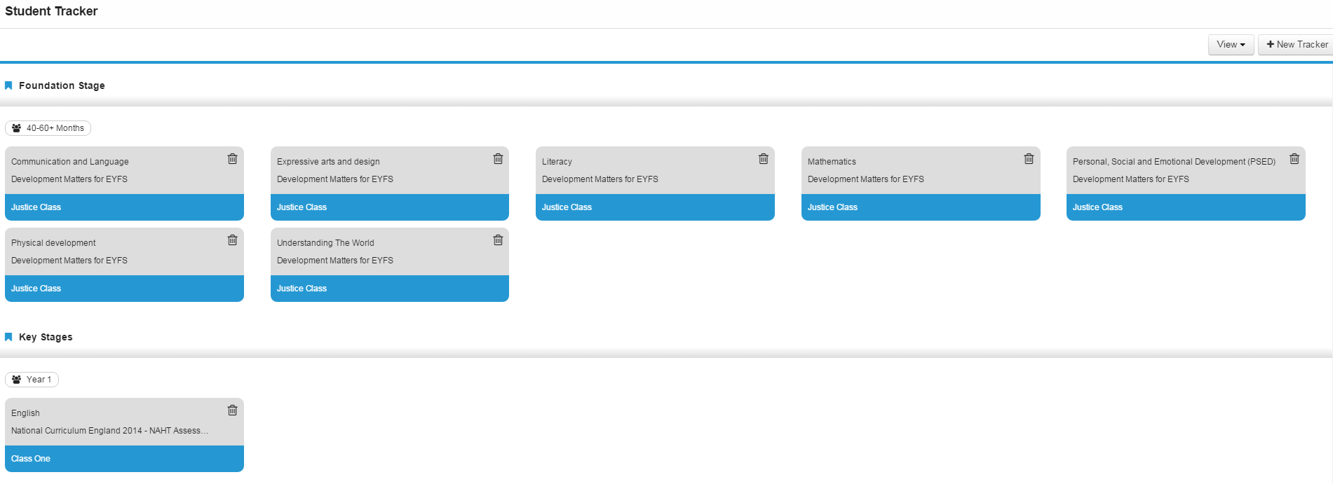If you have created some trackers before, or the view is switched to **All Trackers** then you will see small cards showing each of the trackers that have previously been created.

## Creating a new tracker

To create a new tracker, click the grey **+ New Tracker** button.

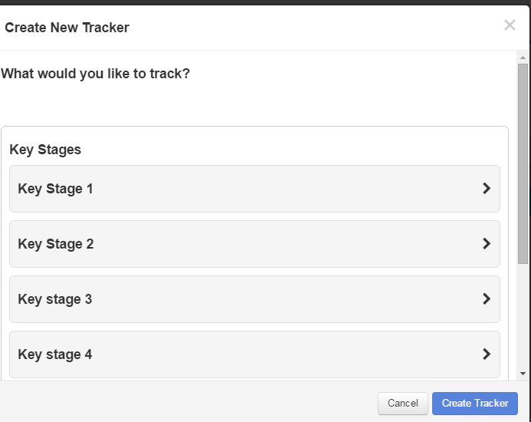You will be presented with the **Create New Tracker** screen. Trackers are created for specific areas of the curriculum and so the first step is to choose your **Key Stage**.

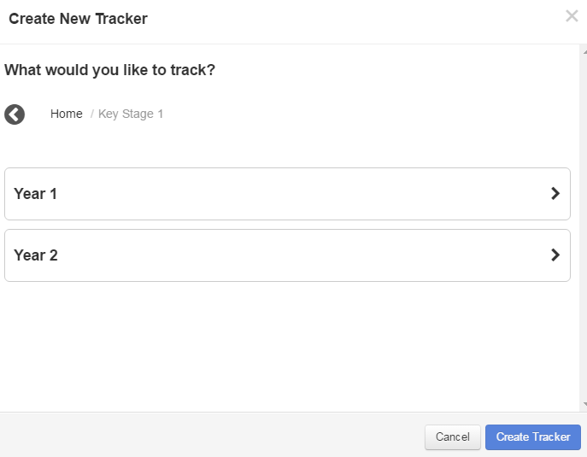Once you have chosen your **Key Stage**, you will be asked to choose a **Year.**

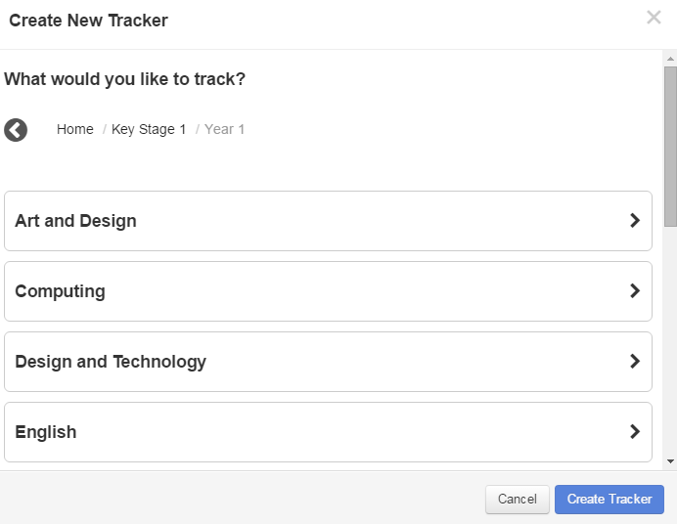

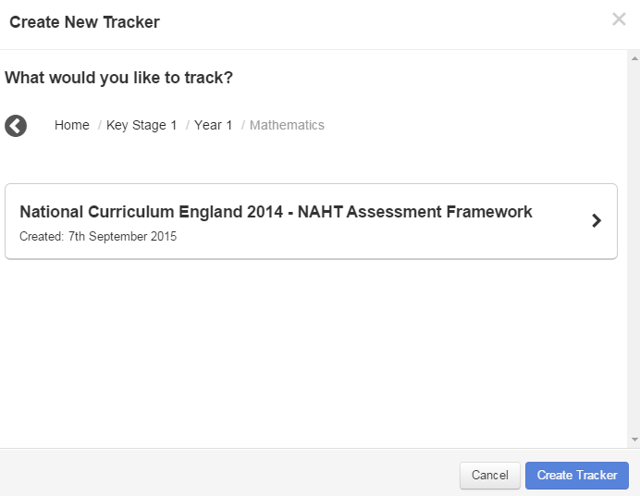

When you have selected your **Year**, you will be presented with a list of **subjects**. Choose your subject from the list. You will then be presented with a list of available curricula within that subject. Choose your **curriculum**.

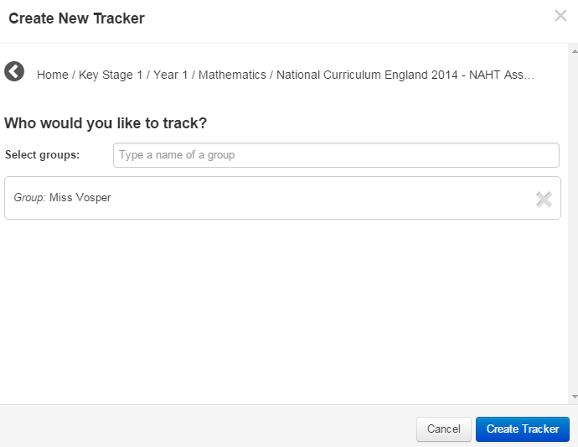You will then be asked who you would like to track. Trackers are created for groups, and so the prompt will ask you to type the **name of a group**. The field is predictive so simply start typing the name of the group you wish to use and it will appear in a drop down.

**Single click** on the group to select is and hit **Create Tracker.**

The screen will refresh to show you your newly created tracker. The Learning Objectives and KPIs from the curriculum and subject you have chosen will be shown down the left. The students in the group you have chosen will be shown along the top.

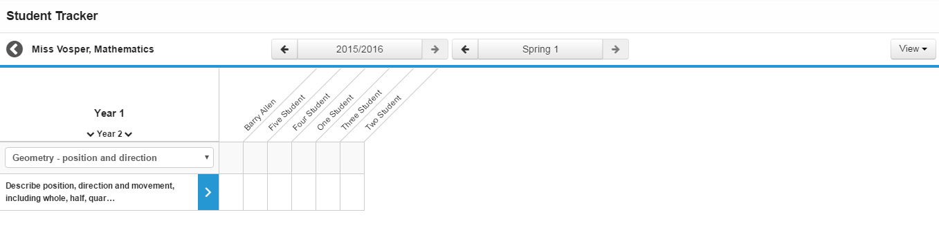

|  |  |
| --- | --- |
|  | **Group name and back arrow:** The name of the tracker is displayed in the top left hand corner, along with a back arrow to get you back to the first page of the Student Tracker application. |
|  | **Year roller:** The Year roller allows you to switch between year groups within a Key Stage (if available in the settings you have chosen). This means that it is easy to track students within your tracker against previous and next year KPIs if they are working above or below the age expected level. |
|  | **Subject Areas:** Certain subjects contain subject areas. Use this drop down to navigate between the different subject areas. For more information on creating subject areas, please see Module Two: Curriculum Manager. |
|  | **Cycle:** This selector allows you to navigate to previous cycles. This could be used to see how students performed in previous academic years. |
|  | **Period:** This selector allows you to navigate through previous periods within the selected cycle. This could be used if a teacher needs to add evidence or judgements for a previous cycle. |
|  | **View:** Use this drop down to change your view between all Learning Objectives or just KPIs, and to choose whether to view colours, values or both. |

## Deleting a tracker

To delete a tracker, open Student Tracker and find the correct tracker card. In the bottom right hand corner of each tracker card is a small dustbin icon.

 Select this to delete the tracker. You will be presented with a warning:

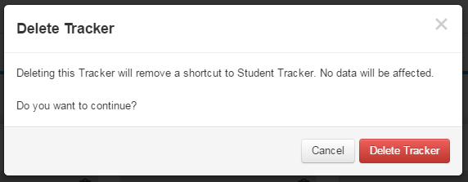

**Note:** **Deleting a tracker will not remove evidence or judgements for any student. The only way to remove evidence or judgement is to remove it manually using the methods outlined later on in this module.**

## Adding a judgement

To add a judgement to a student within Student Tracker, click on the square that corresponds to the student and learning objective you wish to add your judgement against.

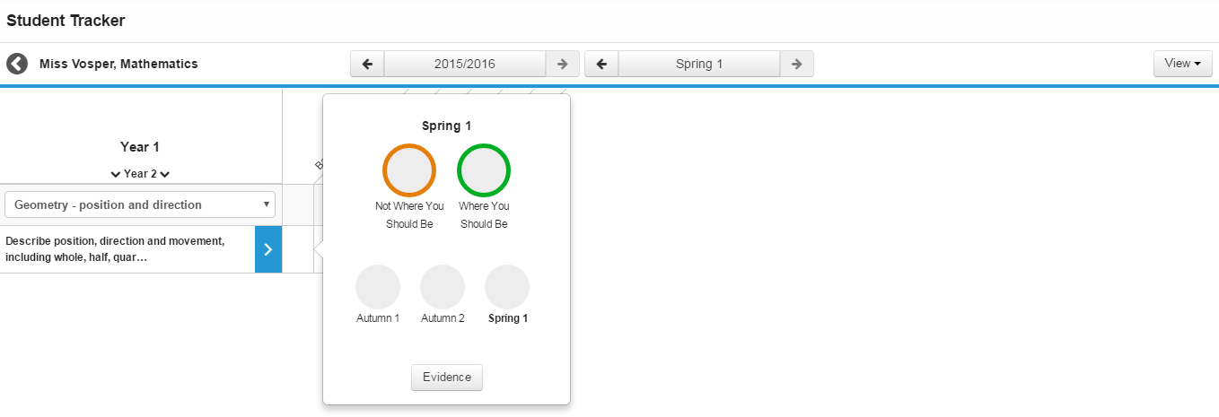

This will give you the judgement and evidence popover window for that student and learning objective.

To add a judgement for that student, single click on the coloured circle for the judgement you wish to use.

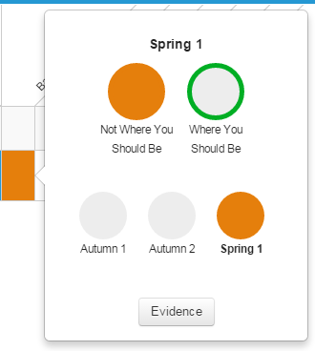

You will be able to see that the square for that student in the tracker changes to reflect the judgement you have made.

In the popover you will see that the judgement you have selected is now completely shaded.

The judgement timeline at the base of this window has also been shaded to show when the judgement has been made.

It is possible to add a judgement to an entire Learning Objective or KPI in one go. To do this, select the blue **>** icon next to the Learning Objective or KPI.

This will give you a popover containing the available statuses. Choose the status you wish to set for the Learning Objective or KPI by selecting it as above. You will see that the entire row of students now has this judgement assigned.

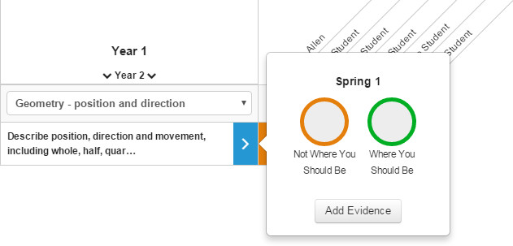

**NOTE: It is not currently possible to remove the judgement for the entire row. Please ensure that you are happy to set this judgement for all students before setting it. To remove the judgements, each must be removed manually – as in the instructions below.**

## Removing a judgement

To remove a judgement, follow the steps above to open the popover for the desired student and Learning Objective.

To remove the judgement, single click on the coloured circle showing the latest judgement. This will remove it from the system.

If another judgement has previously been made, the circle will show the colour of the previous judgement. To remove this judgement, use the **Period selector** to navigate back to when that judgement was set, and remove it in the same way.

## Adding Evidence

To add evidence against a student or students, open your tracker and select the relevant student and Learning Objective. When the popover opens, select the Evidence button to be taken to the **Evidence Timeline**.

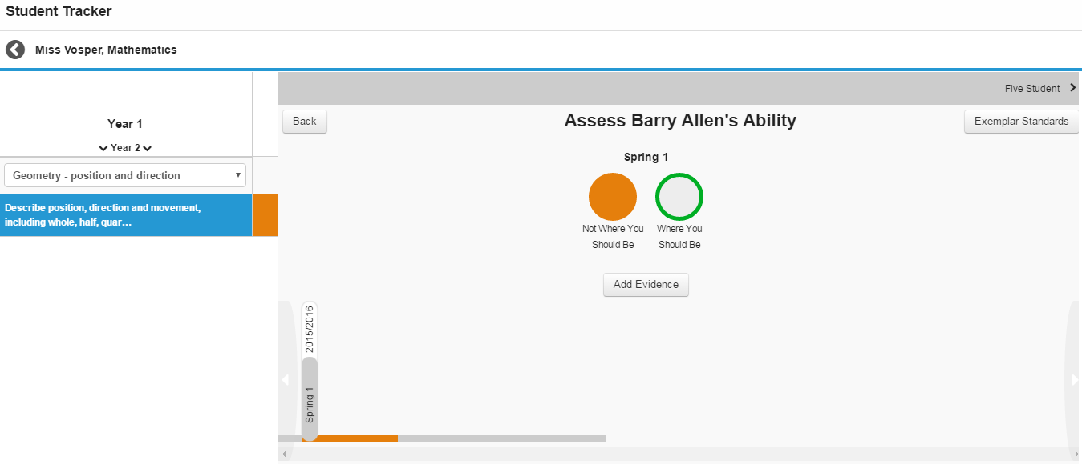

Use the **Add Evidence** button to open the **Add Evidence** window.

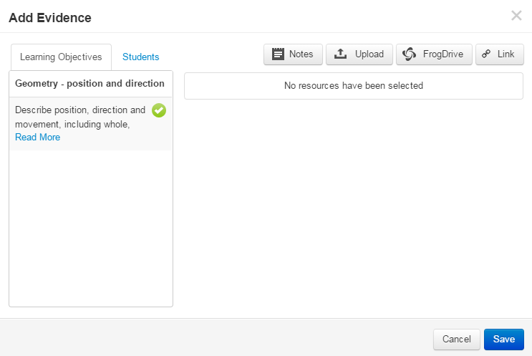There are four different types of evidence which can be added in this window:

**Notes:** Text notes which allow you to type in a simple statement as evidence.

**Upload**: Upload files from your computer or network as evidence.

**FrogDrive (FrogLearn customers only):** Attach files which have already been uploaded into FrogDrive. At this time it is not possible to upload sites as evidence.

**Link:** Attach a weblink as evidence.

In subject areas with multiple Learning Objectives/KPIS, the **Learning Objectives** tab allows teachers to attach evidence to multiple Learning Objectives at once.

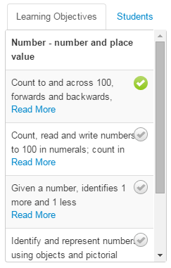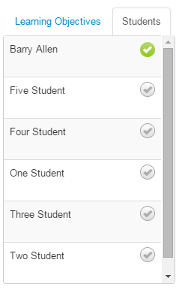To attach a piece of evidence to multiple Learning Objectives, select the tick icons on the right hand side of the list. Those objectives with a green tick will have the evidence attached to them. This is ideal for pieces of work that show evidence of multiple learning objectives at work.

In a similar vein, it is possible to add evidence to multiple students in one go using the **Students** tab.

Select the grey ticks next to the student names to turn them green and choose them to receive the piece of evidence.

When you have chosen which pieces of evidence you wish to add, it is possible to add a comment to each piece of evidence for further explanation if required.

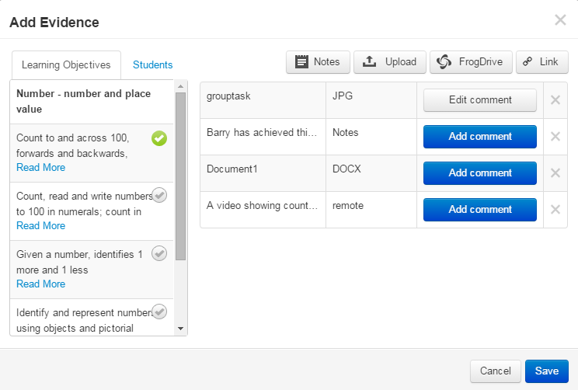

When you are happy with the evidence you have selected, click the blue **Save** button.

The evidence will then be visible on the **Evidence Timeline** of the selected students for those Learning Objectives selected.

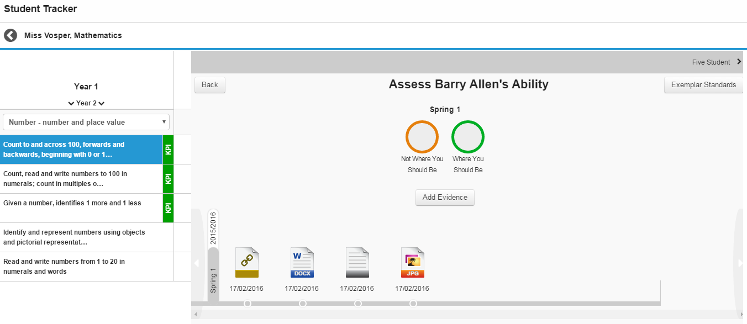

To view any of the pieces of evidence, single click on the icon and you will be presented with a **Preview** window.

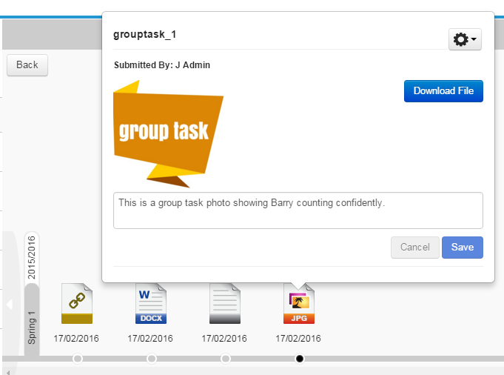In this window you will be able to:

**Preview:** If the file type can be previewed within Frog Progress you will see a thumbnail preview.

**Download File:** The option is provided to download the file to your local machine.

**Notes:** Any notes that have been added to the evidence or a text area to type new notes.

**Submitted By:** Who has uploaded the evidence.

There is also an **Action Cog** in the top right corner which contains two options:

**Send To Standards File:** If the piece of evidence which has been uploaded is a particularly good example of a student achieving that KPI, the teacher can choose to send the file to the Exemplar Standards section of the Learning Locker.

There is an approval process to be accomplished before the file will be shown to members of staff within Student Tracker. Further information on this process can be found in **Module Two: Curriculum Manager**.

**Remove From Evidence:** If the evidence needs to be removed from the student, for example if it has been added in error, this button will remove the evidence file.

## Exemplar Standards

Within the Evidence Timeline attached to each student and Learning Objective, there is an **Exemplar Standards** button. This links to the Exemplar Standards area of the Learning Locker and when selected, will show any materials added for that particularly Learning Objective. 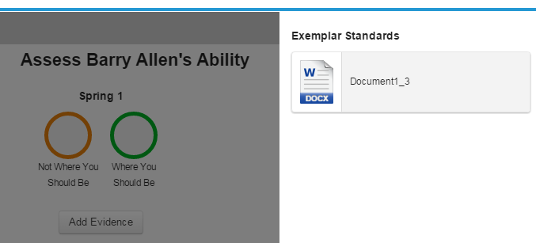

Teachers can click on the file icons provided to see more detail about the file and to download it if required.

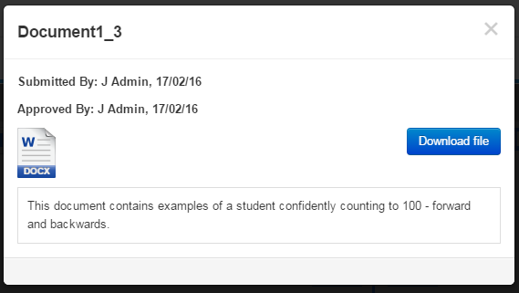

For more information on adding Exemplar Standards to the Learning Locker, please see **Module Two: Curriculum Manager**.

## Evidence Timeline

Using the **Evidence Timeline** it is possible to track back and see the progress made by an individual student.

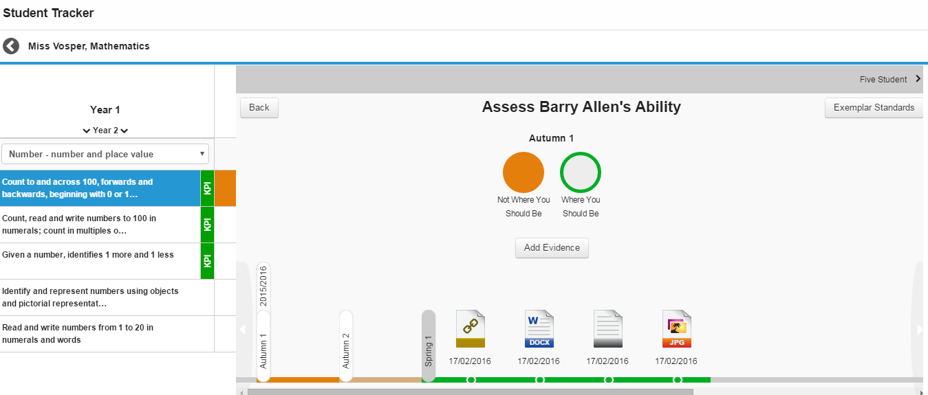

To move backwards or forwards through time, select the light grey arrow buttons at either end of the **Evidence Timeline**.

Please note it is not possible to move forwards beyond the current period.

The bar on the timeline will change colour to reflect the student’s progress at that period in time. Any evidence added during that period will be reflected in that period. The period currently selected will also appear under the student’s name above the judgement circles.